Siuslaw National Forest Documentation Form
Forest Stop Name: Date of visit:
Use any name you wish (i.e. your first or last name), followed by the road number. Put FS before the road number. Multiple stops on the same road, road number followed by 1, 2, 3, etc.
Name Example: Jones-FS 2300-1
Latitude and longitude of where you stopped:
GPS DM or DMs location. Latitude:
Longitude:
Compass Direction of forest stand to visit from road (Check One)
N NE E SE S SW W NW
Elevation:
I-Phone compass provides altitude and lat-long location.
Road Number from official Siuslaw Road Map:
Two Location Questions:
What is or are the closest main highway(s)?
What is the closest town?
Choose a typical tall canopy tree to measure. See graphic below.
Measured Tree Circumference in inches: = Diameter in inches:
Inches circumference divided by 3.141 = diameter in inches.
For example, if the tree is 182 inches around, it is a hair less than 58 inches in diameter.
The measured tree is a (check one) Doug fir Western Hemlock Other
Attention: A group of similar height trees will make up the tall trees in the stand. This is the dominant canopy. Measure a typical or average tree of those tall trees.
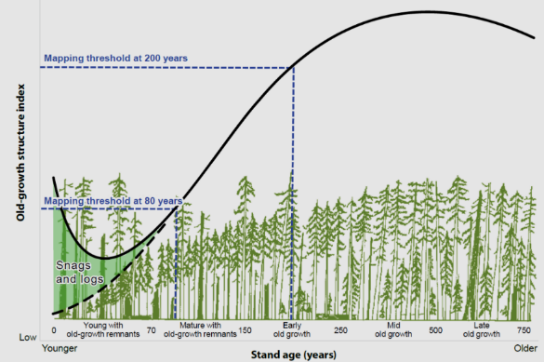
The dominant canopy
of tall trees

Typical tall tree species-check one. Doug fir: Western Hemlock:
Don’t know:
Place an X next to the name of all tree species present in the stand. Doug fir:
Hemlock: Cedar: Sitka Spruce: Alder: Big Leaf Maple:
Is a shade tolerant understory of Hemlock or Cedar present? Yes: X No:

Shade tolerant understory
Usually hemlock and/or cedar

Attention - Keeping Track of the right form to the right photos.
Suggestion 1: Write the name of your forest stop on a piece of paper and hold it in the forest’s view when taking the photo.

Insert Stand Photo. Attention: Your smart phone often takes a picture that is 2,000 by 3,000 pixels. If possible, reduce the pixel size to 800 x 600 range before placing it in the form document. If you use the Microsoft operating system, Paint is the app to use for changing a picture’s pixel size.
Place Stand Photo Below Forest Stop Name:

Photo of Measured Tree:

